ESGenius: Evidence-Grounded, Human-in-the-Loop Gap Analysis of SEBI BRSR Disclosures Using Lexical Retrieval and Batched LLM Classification
Aditya Sinha  Department of Computer Engineering  Vidyalankar Institute of Technology, Wadala, Mumbai, India | Sehaj Alag  Department of Computer Engineering  Vidyalankar Institute of Technology, Wadala, Mumbai, India | Pradnesh Jadhav  Department of Computer Engineering  Vidyalankar Institute of Technology, Wadala, Mumbai, India | Gaurav Deore  Department of Computer Engineering  Vidyalankar Institute of Technology, Wadala, Mumbai, India

Abstract - Listed Indian companies must file a Business Responsibility and Sustainability Report (BRSR) that answers 140 questions set by the Securities and Exchange Board of India (SEBI). Checking a draft report against every question by hand is slow and easy to get wrong. This paper presents ESGenius, a web-based decision-support tool that takes a sustainability PDF, finds page-cited evidence for each BRSR question, and labels each question as covered, partially covered, not covered or requiring human review. Evidence is selected without a language model: the report is split into page-bounded chunks and ranked with a BM25-style scorer extended with ESG term aliases, phrase anchors and a discriminative-term gate. A large language model (Google Gemini) is used only for classification, and requirements are batched by BRSR section so that a full 140-question analysis needs 15 model calls instead of 140. Two fallbacks stop the model from inventing coverage: when no evidence is retrieved, the question is marked not covered without a model call, and when a model call fails, the question is sent to human review required. On the Infosys BRSR, the retriever returned evidence for all 140 questions. In our audit, the top-ranked passage was relevant for 119 (85.0%) and at least partially relevant for 129 (92.1%) of them. Most errors come from short company-identity fields in the general disclosures and from the tabular layout of the management and process disclosures. The system is a prototype that supports professional judgement and does not replace it.
Index Terms - ESG reporting, SEBI BRSR, retrieval-augmented generation, BM25, large language models, compliance gap analysis, document understanding
I. INTRODUCTION
Environmental, social and governance (ESG) disclosure has moved from voluntary reporting to a regulatory requirement. In India, SEBI requires the top listed entities to publish a Business Responsibility and Sustainability Report (BRSR) as part of their annual report. The BRSR format has 140 numbered questions: general disclosures, management and process disclosures and, for each of the nine principles of the National Guidelines on Responsible Business Conduct, Essential and Leadership indicators.
Before filing, a sustainability team has to confirm that the draft answers every question and that each answer is backed by data. The reports often run past 100 pages and mix prose with multi-column tables, so this is slow reading work. It is repetitive, varies from reviewer to reviewer, and gaps are often found late. Large language models (LLMs) can read and summarise such documents, but using them directly for compliance work is risky: a model may claim that a disclosure exists when it does not, and its answers are hard to trace to a source page .
This paper describes ESGenius, a prototype that treats the model as one step in a controlled pipeline rather than as the decision maker. Its contributions are:
(1) A page-aware ingestion and retrieval pipeline that ties every piece of evidence to a PDF page number and selects it without a model, using a BM25-style lexical scorer with ESG term aliases, phrase anchors and gating rules.
(2) Section-batched LLM classification that cuts a full 140-question analysis from 140 model calls to 15, so a complete analysis fits within a free-tier quota of 20 requests per day.
(3) A fail-safe decision policy: absence of evidence is classified as not covered by rule, and any model failure falls back to human review required instead of a guess.
(4) An end-to-end implementation with authentication, per-user document ownership, usage limits, asynchronous processing, progress reporting and a PDF gap-assessment export, together with a retrieval audit on a real BRSR.
The rest of the paper is organised as follows. Section II reviews related work, Section III presents the architecture, Section IV describes the method, Section V summarises the implementation and testing, Section VI reports the evaluation, and Sections VII and VIII cover limitations and conclusions.
II. BACKGROUND AND RELATED WORK
A. The BRSR Framework
SEBI introduced the BRSR through circular SEBI/HO/CFD/CMD-2/P/CIR/2021/562 of 10 May 2021. ESGenius stores the 140 questions of the original Annexure I format as framework requirements, each with a code, title, description, section, indicator type and framework text. Table I shows how the requirement set breaks down. Later revisions of the format (BRSR Core, value-chain and assurance requirements) are outside the scope of this work.
TABLE I
BRSR REQUIREMENT SET AND BATCH PLAN (L = 12)
Section | Gen./Ess. | Lead. | Total | Calls
General | 24 | - | 24 | 2
Management | 12 | - | 12 | 1
P1 | 7 | 2 | 9 | 1
P2 | 4 | 5 | 9 | 1
P3 | 15 | 6 | 21 | 2
P4 | 2 | 3 | 5 | 1
P5 | 10 | 5 | 15 | 2
P6 | 12 | 9 | 21 | 2
P7 | 2 | 1 | 3 | 1
P8 | 4 | 6 | 10 | 1
P9 | 6 | 5 | 11 | 1
Total | 98 | 42 | 140 | 15

B. NLP for Corporate Sustainability Reports
Domain-adapted language models such as ClimateBERT [6] and datasets such as ClimaText focus on classifying climate-related text, for instance deciding whether a sentence is about climate risk. ChatReport lets an LLM answer questions about sustainability reports and links its answers to source passages, as a response to the hallucination problem. ESGenius differs in its goal and in how control is handled, it maps a document onto a fixed, legally defined set of questions, gives each question a status, and limits what the model is allowed to decide.
C. Retrieval-Augmented Generation
Retrieval-augmented generation (RAG) grounds a generator in retrieved passages. Dense retrieval is common, but lexical BM25 is still a strong zero-shot baseline across very different collections. Regulatory questionnaires use stable, domain-specific vocabulary. A lexical retriever is cheap, needs no embedding service, is deterministic, and its scores can be inspected. For these reasons ESGenius retrieves lexically and keeps the LLM for the judgement step only. Long prompts can also weaken a model’s use of information placed in the middle of the context, which is why we keep retrieved evidence short and cap the batch size.
III. SYSTEM ARCHITECTURE
ESGenius is a three-tier web application. The frontend is a React 19 app built with TanStack Start, Router and Query on Vite and TypeScript. The backend is a Java 21 / Spring Boot 3.4 service with a versioned REST API. Data is stored in PostgreSQL, with the schema managed by 12 Flyway migrations and checked against the JPA entities at start-up. Uploaded PDFs are kept on the server file system, while metadata, per-page text and analysis results are kept in the database.
Authentication and access control. Users sign in with Supabase Auth. The frontend sends the access token as a bearer token, and a servlet filter validates it against Supabase and caches successful validations under a SHA-256 digest of the token. Every document belongs to the user who uploaded it. Seeded sample documents have no owner and are view-only, except for administrators. A request for another user’s private document returns 404.
Asynchronous processing. An upload returns immediately with status PROCESSING, while a bounded background executor extracts the text (Apache PDFBox, without OCR) and stores it page by page. A compliance analysis also runs on its own executor, and the UI polls its status. If the server restarts while a document or analysis is in progress, that job is marked FAILED at start-up so that no job stays pending forever.
Resource protection. Uploads are limited to 25 MB, 400 pages and three million extracted characters. Rolling per-user limits apply to uploads (20 per day), analyses (5 per day) and assistant questions (30 per hour), and a global cap of 20 analyses per day protects the shared model quota. Requests over a limit receive HTTP 429 with a Retry-After header.
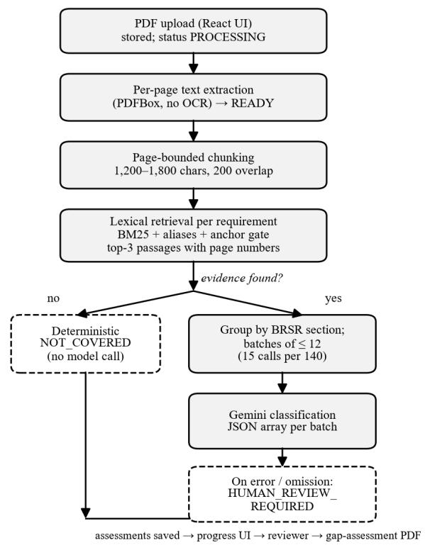
Fig. 1. ESGenius analysis pipeline. Dashed boxes are the deterministic fail-safe paths.
IV. METHOD
A. Page-Aware Chunking
The extracted text is kept per page. Each page is split into chunks of about 1,200–1,800 characters, preferably at a newline, full stop or semicolon, with a 200-character overlap. A chunk never crosses a page boundary, so every retrieved passage has an exact 1-based page number, which is later shown to the reviewer and printed in the report.
B. Lexical Evidence Retrieval
For each requirement we build a weighted query from its code (weight 3.0), title (6.0) and description (2.5). Stop-words and a list of generic BRSR words (for example entity, report, policy) are removed. Curated ESG aliases are added at 0.85 of the weight of the term they stand for, for example bribery for corruption or kilolitres for water. Each chunk is split into sentence-level passages, and every passage p is scored against every query term t with a BM25 term score:
s(t,p) = w_{t} · idf(t) · tf_{t,p}(k₁+1) / (tf_{t,p} + k₁(1 − b + b·|p| / L̄)) (1)
where wₜ is the field weight of the term, tf the term frequency in the passage, |p| the passage length in tokens and L̄ the mean chunk length of the document. The constants are k₁ = 1.2 and b = 0.75, and the inverse document frequency is computed over the chunks of the uploaded document:
idf(t) = max( ln( (N − df_{t} + 0.5) / (df_{t} + 0.5) + 1 ), 0.05 ) (2)
with N the number of chunks; for generic terms the raw value is first multiplied by 0.05. Because scoring is done on passages inside a chunk, the best-matching sentence is returned instead of the whole chunk. The passage score then adds bonuses for phrase-level evidence:
S(p) = max( 0, Σ_{t} s(t,p) + 5·A(p) + 4·L(p) + 8·R(p) + 10·C(p) − 40·F(p) ) (3)
where A counts matched title or description phrase anchors, L counts matched alias phrases, R is 1 if a required-anchor phrase occurs (stop-words may sit between its tokens, so waste recycled also matches waste was recycled), C is 1 if the Scope number in the requirement title occurs in the passage, and F counts forbidden phrases. A passage that names a different GHG Scope than the requirement is rejected outright, which is how the Scope 1, 2 and 3 questions are kept apart.
A passage is eligible only if it passes an anchor gate, it must match a required anchor if the requirement defines one; otherwise it must contain an anchor or alias phrase, or at least two non-generic discriminative query terms. The gate stops passages from ranking high just because they contain common words. We return the three highest-scoring chunks whose best passage scores at least 0.15, together with their page numbers. If none qualifies, the requirement has no evidence. Curated required-anchor and forbidden-phrase lists exist only for the original 14 prototype requirements, so the audit in Section VI tests the generic path that applies to all 140 questions.
C. Evidence Preparation
A matched passage is often only a sentence fragment, so before classification it is widened inside its chunk, taking 350 characters before the match and 550 after, up to a maximum of 1,800 characters. This gives the model local context, such as a table heading, without sending the whole page.
D. Section-Batched Classification
Requirements that have evidence are classified by Google Gemini into one of four statuses: COVERED, PARTIALLY-COVERED,NOT-COVERED,or..HUMAN-REVIEW-REQUIRED. Each status comes with a confidence, an explanation, a gap and a recommendation. The prompt fixes the model’s role, the requirement’s title, description and framework text are declared the complete rubric, and the model must not bring in criteria from its own knowledge of the BRSR, SEBI or other standards, must not judge whether a metric is good or bad, and must not claim certification.
Sending one request per question would need 140 calls per analysis. The free-tier quota of the model we used was 20 requests per day, so requirements are grouped by BRSR part (general disclosures, management and process, and Principles P1–P9) and each group is split as evenly as possible into the fewest batches of at most L = 12 requirements. For a group of n requirements, the number of batches is m = ⌈n/L⌉ and the batch sizes are ⌊n/m⌋ or ⌊n/m⌋ + 1. Each prompt lists, for every requirement, its own rubric and its own evidence passages, tells the model to judge each one independently, and asks for a JSON array keyed by requirement code. Grouping by section keeps related questions together and each call short. For the full BRSR this gives 15 calls.
TABLE II
MODEL CALLS PER FULL ANALYSIS (140 REQUIREMENTS)
Strategy | Calls | Fits 20/day?
One call per requirement | 140 | No
Section batches, L = 12 | 15 | Yes (5 spare)

E. Fail-Safe Decision Policy
The model never creates coverage on its own. (i) A requirement with no retrieved evidence is classified NOT-COVERED by a deterministic classifier, with confidence 0.75 and no model call. (ii) If the model leaves out a requirement or returns an invalid entry, only that requirement falls back to HUMAN-REVIEW-REQUIRED. (iii) If a call fails, all requirements in that batch fall back to HUMAN-REVIEW-REQUIRED. (iv) Retryable errors are retried with exponential backoff and respect any retry delay supplied by the server; once the daily quota is used up, the remaining calls are skipped and the explanation shown to the user gives the quota as the reason. The result is deliberately lopsided: errors push work to a person instead of producing a false COVERED.
V. IMPLEMENTATION AND TESTING
Besides gap analysis, the system includes a document-grounded assistant that answers questions about one uploaded document. It retrieves passages with the same lexical retriever and cites them, and when nothing matches, it returns a fixed not-found answer with the flag grounded = false and does not call the model. Completed analyses can be exported as a Gap Assessment PDF that includes page citations and a disclaimer that the output is prototype decision support and needs human validation. A company-comparison view shows seeded, illustrative ESG scores; these are not model outputs and are labelled as prototype data.
Development was tracked with Git and GitHub. The repository holds 90 commits between 14 August and 20 October 2026. At the time of writing it contains 370 backend JUnit test methods and 124 frontend Vitest cases. Backend tests run on an in-memory H2 database in PostgreSQL mode using the same Flyway scripts; the live model and live authentication are replaced by in-process fakes or mocked HTTP servers, so tests never call external services. Dedicated tests cover batch planning (the limit holds for every limit and size combination, and 140 requirements give 15 calls), prompt construction, parsing of partial or malformed model answers, quota handling, recovery of interrupted jobs, ownership rules and rate limiting.
VI. EVALUATION
A. Setup
We evaluated the retrieval stage on the Infosys Limited BRSR for the financial year April 2024 to March 2025, a publicly available 49-page report that produced 92 chunks. All 140 active requirements were run through the production retriever, and no model was called. For each requirement, the top-ranked passage was compared with the requirement title and marked relevant (the passage is the disclosure, or its table or question text), partially relevant (a related but different disclosure) or not relevant. This measures whether the top result is on topic (precision at 1), not whether the disclosed value is correct. A per-requirement listing is provided as supplementary material.
B. Retrieval Results
The retriever returned at least one passage for all 140 requirements (140 of 140). Table III and Fig. 2 show the audit outcome. The top passage was relevant for 119 requirements (85.0%) and at least partially relevant for 129 (92.1%). Results were strongest for the nine principles (96 of 104 relevant, 92.3%), where the questions are long and descriptive, and every question for Principles 1–4 and 7–8 was relevant. They were weakest in the management and process disclosures (5 of 12, 41.7%) and the general disclosures (18 of 24, 75.0%).
TABLE III
TOP-1 RETRIEVAL AUDIT ON THE INFOSYS BRSR FY 2024-25
Group | n | Rel. | Part. | Not | P@1
General | 24 | 18 | 2 | 4 | 75.0%
Mgmt. & process | 12 | 5 | 4 | 3 | 41.7%
Principles 1-9 | 104 | 96 | 4 | 4 | 92.3%
All | 140 | 119 | 10 | 11 | 85.0%
P@1: share of requirements whose top passage is relevant (strict).
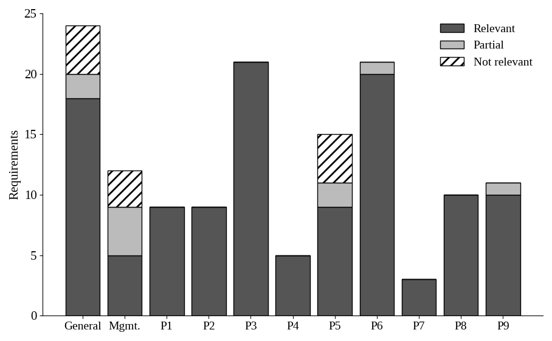
Fig. 2. Top-1 retrieval audit by BRSR part (n = 140).
Error analysis. The 11 non-relevant results fall into three groups. First, four short identity fields in the general disclosures (corporate address, e-mail, website, paid-up capital) returned generic header or contact lines such as Name of the Listed Entity. Second, several questions use the same vocabulary and compete for one passage: four Principle 5 questions (human-rights complaints, assessments of plants, value-chain assessments and corrective action) all returned the same passage on the scope and coverage of human rights due diligence, with an identical score (103.9). Third, three management and process questions (extension of policies to the value chain, targets, reasons for uncovered principles) returned text from other sections. We did not look into the causes in depth, one plausible factor is that these answers are given in a multi-column table that a line-based text extractor flattens, which fits the limits of lexical, line-based retrieval discussed in Section VII.
C. Model-Call Budget
Table II compares call budgets. Without batching, a full analysis needs one call per requirement with evidence, up to 140, which cannot finish under a 20-request daily quota. Section batching needs 15 calls and leaves five for retries and other use. The first prototype, with 14 requirements, used 14 calls per analysis and already consumed most of the daily quota, so extending to the full set made batching necessary.
D. Threats to Validity
The retrieval audit uses a single report from one large IT company that follows the BRSR format closely, so the results may not carry over to reports with other layouts or to scanned documents. The grading was done by a single rater, an AI assistant, and its labels were not checked by human raters, so no inter-rater agreement is available and the figures should be treated as indicative until a human re-grade is done. Because the report discloses nearly every item, the evidence-absent path (deterministic NOT-COVERED) was not exercised on real data. Finally, the quality of the LLM classification itself (agreement with expert labels) has not yet been measured; this needs an expert-labelled corpus and live model quota, and is the main item of future work.
VII. LIMITATIONS AND FUTURE WORK
Scope. Only the original BRSR Annexure I format is supported; BRSR Core, value-chain and assurance disclosures are not. Other frameworks (GRI, IFRS S1/S2, ESRS) are only planned. Retrieval. Lexical, line-based retrieval is weak on multi-column tables and on short factual fields; table-aware extraction and hybrid lexical-dense retrieval are the natural next steps. Documents. There is no OCR, so scanned PDFs are rejected. Batching. Requirements in a batch share one call, so one failed call affects up to 12 requirements, and by design an answer cannot use another requirement’s evidence. Operations. Rate limits are held in memory per instance and the file store is local, which limits horizontal scaling. Evaluation. We plan an expert-labelled benchmark of several BRSR reports to measure classification accuracy, calibration of the confidence value and the reduction in reviewer time.
Responsible use. ESGenius classifies disclosure coverage, not ESG performance, and it does not certify compliance. Its output is meant to direct a human reviewer’s attention, and the interface, the exported PDF and the model prompt all say so.
VIII. CONCLUSION
We presented ESGenius, a pipeline that checks a sustainability report against the 140 questions of the SEBI BRSR and cites the page for each piece of evidence. By combining deterministic lexical retrieval, section-batched LLM classification and conservative fallbacks, the system completes an analysis in 15 model calls, and neither missing evidence nor a model failure can produce a claim of compliance. In an audit on a real BRSR, the top-ranked evidence was relevant for 85.0% of questions, with clear weak spots in identity fields and tables. Future work will measure classification quality against expert labels and add table-aware and hybrid retrieval.
ACKNOWLEDGMENT
The authors thank their project mentor, Dr. Amit Aylani, for his guidance during the project. The authors used AI tools during this work- Claude, Cursor and Antigravity for coding assistance during system development, ChatGPT and Gemini for background research, and Claude for the initial structure and language editing of this manuscript. The authors revised the text, verified the technical content and results, and take full responsibility for the paper.
REFERENCES
[1] Securities and Exchange Board of India, “Business responsibility and sustainability reporting by listed entities,” Circular SEBI/HO/CFD/CMD-2/P/CIR/2021/562, May 10, 2021.
[2] S. Robertson and H. Zaragoza, “The probabilistic relevance framework: BM25 and beyond,” Found. Trends Inf. Retr., vol. 3, no. 4, pp. 333–389, 2009.
[3] P. Lewis et al., “Retrieval-augmented generation for knowledge-intensive NLP tasks,” in Proc. Adv. Neural Inf. Process. Syst. (NeurIPS), vol. 33, 2020, pp. 9459–9474.
[4] Y. Gao et al., “Retrieval-augmented generation for large language models: A survey,” arXiv:2312.10997, 2023.
[5] J. Ni et al., “ChatReport: Democratizing sustainability disclosure analysis through LLM-based tools,” in Proc. EMNLP 2023 System Demonstrations, Singapore, Dec. 2023, pp. 21–51, doi: 10.18653/v1/2023.emnlp-demo.3.
[6] N. Webersinke, M. Kraus, J. A. Bingler, and M. Leippold, “ClimateBERT: A pretrained language model for climate-related text,” arXiv:2110.12010, 2021.
[7] F. S. Varini, J. Boyd-Graber, M. Ciaramita, and M. Leippold, “ClimaText: A dataset for climate change topic detection,” arXiv:2012.00483, 2020.
[8] N. Thakur, N. Reimers, A. Rücklé, A. Srivastava, and I. Gurevych, “BEIR: A heterogeneous benchmark for zero-shot evaluation of information retrieval models,” in Proc. NeurIPS Datasets and Benchmarks Track, 2021.
[9] N. F. Liu et al., “Lost in the middle: How language models use long contexts,” Trans. Assoc. Comput. Linguistics, vol. 12, pp. 157–173, 2024.
[10] Z. Ji et al., “Survey of hallucination in natural language generation,” ACM Comput. Surv., vol. 55, no. 12, Art. no. 248, 2023.
[11] Gemini Team, Google, “Gemini: A family of highly capable multimodal models,” arXiv:2312.11805, 2023.
[12] Apache Software Foundation, “Apache PDFBox.” [Online]. Available: https://pdfbox.apache.org

